Parallel Lines
# Source: AI Source: Provided by: [Data Path: Persons Table -> ID Column: 1, Name_En Column: Motasem Essam] -> From: [ChatGPT] on [7/25/2026]
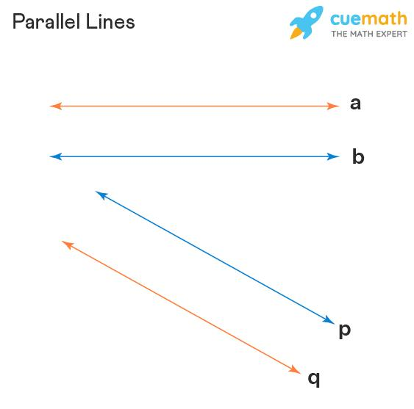
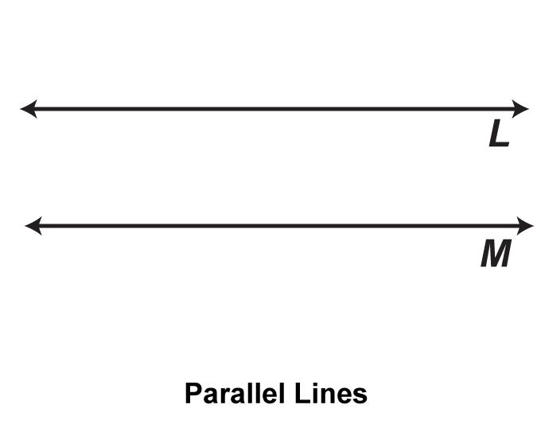
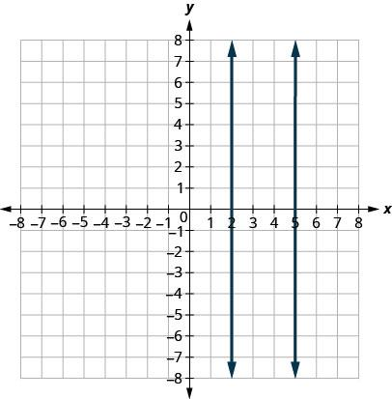
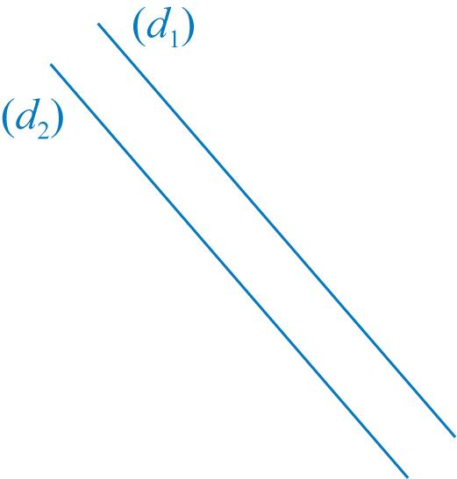
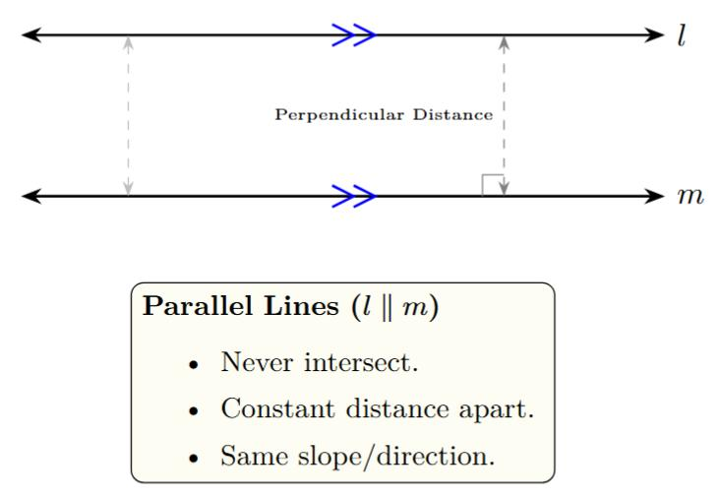
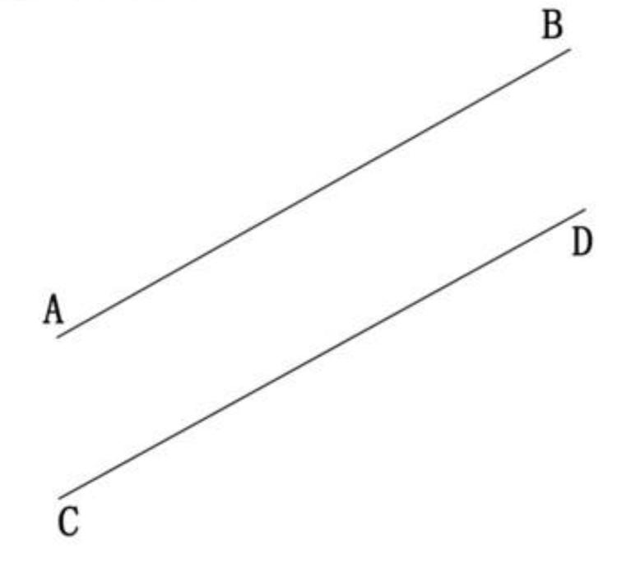

Definition
# Source: AI Source: Provided by: [Data Path: Persons Table -> ID Column: 1, Name_En Column: Motasem Essam] -> From: [ChatGPT] on [7/25/2026]
Parallel Lines are two or more lines in the same plane that never intersect, no matter how far they are extended. They always remain the same distance apart and have the same direction.
In coordinate geometry, parallel lines have equal slopes but different intercepts.

Characteristics
# Source: AI Source: Provided by: [Data Path: Persons Table -> ID Column: 1, Name_En Column: Motasem Essam] -> From: [ChatGPT] on [7/25/2026]
Parallel lines:
- Lie in the same plane (coplanar).
- Never intersect.
- Remain equidistant from each other.
- Have the same direction.
- Have equal slopes.
- May be horizontal, vertical, or oblique.

Illustration
# Source: AI Source: Provided by: [Data Path: Persons Table -> ID Column: 1, Name_En Column: Motasem Essam] -> From: [ChatGPT] on [7/25/2026]
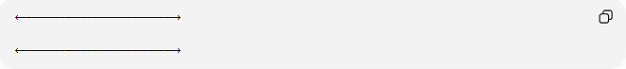
←────────────────────────────→

←────────────────────────────→
The two lines remain the same distance apart and never meet.

Mathematical Representation
# Source: AI Source: Provided by: [Data Path: Persons Table -> ID Column: 1, Name_En Column: Motasem Essam] -> From: [ChatGPT] on [7/25/2026]
Parallelism is represented by the symbol:
$$∥$$
Example:
$$l_{1}∥l_{2}$$

Coordinate Geometry
# Source: AI Source: Provided by: [Data Path: Persons Table -> ID Column: 1, Name_En Column: Motasem Essam] -> From: [ChatGPT] on [7/25/2026]
Two non-vertical lines are parallel if they have the same slope:
$$m_{1}=m_{2}$$
Example:
$$y=2x+3$$
and
$$y=2x-5$$
Both lines have slope:
$$m=2$$
Therefore, they are parallel.

Vertical Parallel Lines
# Source: AI Source: Provided by: [Data Path: Persons Table -> ID Column: 1, Name_En Column: Motasem Essam] -> From: [ChatGPT] on [7/25/2026]
Vertical lines are parallel when they have different x-values.
Example:
$$x=3$$
and
$$x=8$$

Properties
# Source: AI Source: Provided by: [Data Path: Persons Table -> ID Column: 1, Name_En Column: Motasem Essam] -> From: [ChatGPT] on [7/25/2026]
Parallel lines:
- Never intersect.
- Have equal slopes (for non-vertical lines).
- Maintain a constant distance apart.
- Form equal corresponding and alternate interior angles when cut by a transversal.
- Can both be horizontal, both vertical, or both oblique.

Examples
# Source: AI Source: Provided by: [Data Path: Persons Table -> ID Column: 1, Name_En Column: Motasem Essam] -> From: [ChatGPT] on [7/25/2026]
Examples of parallel lines include:
- Railway tracks.
- Opposite edges of a rectangle.
- Ruled notebook lines.
- Parallel roads.
- Floor tiles arranged in rows.

Applications
# Source: AI Source: Provided by: [Data Path: Persons Table -> ID Column: 1, Name_En Column: Motasem Essam] -> From: [ChatGPT] on [7/25/2026]
Parallel lines are used in:
- Plane Geometry
- Coordinate Geometry
- Engineering
- Architecture
- Construction
- Surveying
- CAD (Computer-Aided Design)
- Technical Drawing
- Computer Graphics
- Road and Railway Design

Advantages
# Source: AI Source: Provided by: [Data Path: Persons Table -> ID Column: 1, Name_En Column: Motasem Essam] -> From: [ChatGPT] on [7/25/2026]
Studying parallel lines helps to:
- Analyze geometric relationships.
- Construct accurate geometric figures.
- Solve angle problems.
- Develop engineering and architectural drawings.
- Understand coordinate geometry.

Limitations
# Source: AI Source: Provided by: [Data Path: Persons Table -> ID Column: 1, Name_En Column: Motasem Essam] -> From: [ChatGPT] on [7/25/2026]
Parallel lines:
- Exist only within the same plane.
- Never share a common point.
- Cannot be perpendicular to each other.

Comparison with Other Types of Lines
# Source: AI Source: Provided by: [Data Path: Persons Table -> ID Column: 1, Name_En Column: Motasem Essam] -> From: [ChatGPT] on [7/25/2026]
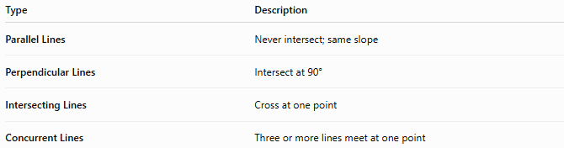
Type | Description
Parallel Lines | Never intersect; same slope
Perpendicular Lines | Intersect at 90°
Intersecting Lines | Cross at one point
Concurrent Lines | Three or more lines meet at one point

Key Points
# Source: AI Source: Provided by: [Data Path: Persons Table -> ID Column: 1, Name_En Column: Motasem Essam] -> From: [ChatGPT] on [7/25/2026]
- Parallel Lines never intersect.
- They remain the same distance apart.
- They are represented by:
$$∥$$
- For non-vertical lines:
$$m_{1}=m_{2}$$
- Parallel lines are widely used in geometry, engineering, architecture, surveying, CAD, and technical drawing.

Conclusion
# Source: AI Source: Provided by: [Data Path: Persons Table -> ID Column: 1, Name_En Column: Motasem Essam] -> From: [ChatGPT] on [7/25/2026]
Parallel Lines are coplanar lines that extend infinitely without ever intersecting, maintaining a constant distance between them. They share the same direction and, in coordinate geometry, have equal slopes while differing in their intercepts. Parallel lines are fundamental in plane geometry, coordinate geometry, engineering, architecture, construction, surveying, CAD, technical drawing, transportation design, and computer graphics, where they are essential for creating accurate layouts, analyzing geometric relationships, and modeling structures.

